

Contents:

* Introduction
* Block Diagram
* Components
* Explanation
* Applications and conclusion

INTRODUCTION:

* Automatic identification and access control system has become necessary to overcome the security threats faced by many organizations . By installing the system at the entrance will only allow the authorized persons to enter the organization . The system can also be installed at various points inside the organization to track the person’s movement and to restrict their access to sensitive areas in the oraganization .

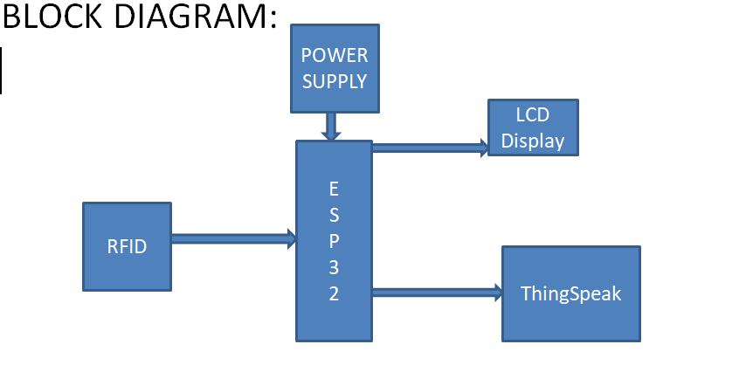

COMPONENTS:

* RFID-RC522
* RFID Tags
* ESP-32S
* Servo Motor
* Connecting Wires

In this project we have used Arduino IDE software.

All RFID systems are comprised of three main components:

– the RFID tag, or transponder, which is located on the object to be identified and is the data carrier in the RFID system.

– the RFID reader, or transceiver, which may be able to both read data from and write data to a transponder.

– the data processing subsystem which utilizes the data obtained from the transceiver in some useful manner.

APPLICATIONS:

* Attendance System
* Intelligent Tollgate System
* Book Tracking in Libraries
* Authentication of Passport Details
* Authentication in Industries

CONCLUSION:

The roadmap towards cheap tags has been laid out, but like any research effort, uncertainty is a part of the challenge. Several technology alternatives will need to be tested for each component of the system before the optimal one is determined. Even after the first cheap tags have been manufactured, scaling production to the volumes needed to meet expected demand will be a challenge. It may be years before the supply meets the enormous demand that a technology of this type is projected to generate. However, it is these very volumes that make it necessary for the technology to be carefully thought out to save every fraction of a cent in the cost of a tag and to ensure the security and privacy of its future users.